**Create Azure Function**

Many times, we need to create Azure Function which can be running scheduled or can be called via HTTP using flow or other technology and perform some task like getting data from Azure AD and creating CSV/JSON and upload to SP list.

**Requirement:** I am getting all users from Azure AD and creating JSON file and uploading back to SharePoint Site.

We need to add dependencies for Pnp powerShell and Azure AD. We need to update these two references which is defined in host.json, requirement.psd1 and profile.ps1 file, added with the project.

**Section 1 : create Scheduled Timer Job**

1. Navigate to <https://portal.azure.com/>
2. In the Search box type “Function App” and select “Function App” from dropdown
3. Click Create >Select Subscription & resource Group> Provide name for web App
4. For Run time stack select PowerShell Core and version 7 and add other details.

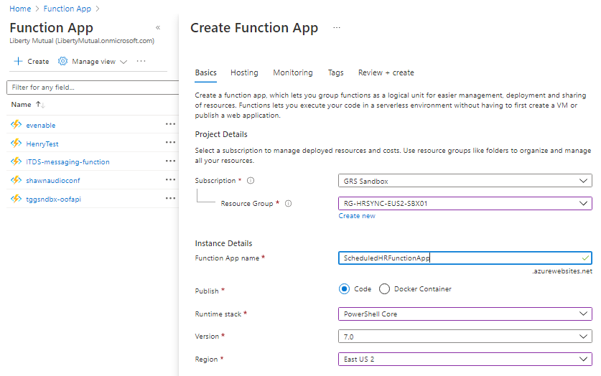

1. For Hosting Tab,

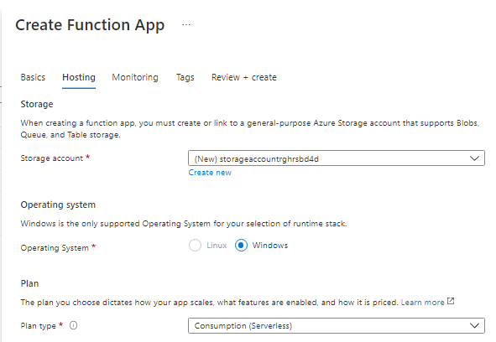

1. For Monitoring, we can enable Application Insight if we want to use logging feature else we can select NO.
2. We can provide some Name, under Tag tab > Review and create.
3. Once Function App is created, click on the function APP and select Functions from left tab.

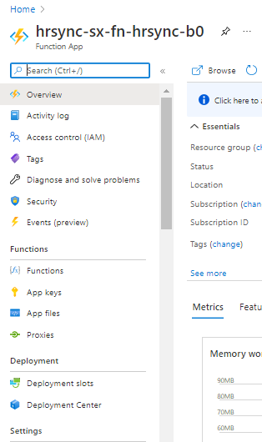

1. Click on Add from Function page and select HTTP trigger if you want to call from Flow and Select Timer trigger if want to create scheduled.

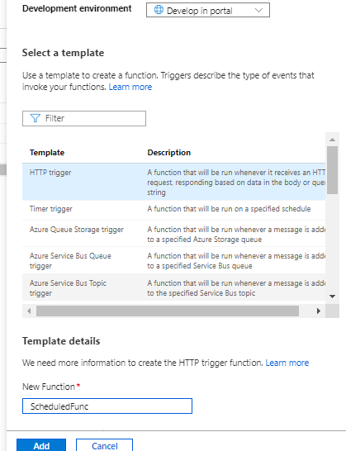

1. Once I have created my timer trigger, we can put our script to run inside. I have added one sample script as ScheduledTimerJob with this file.

**Note:** In Azure we need to store file in local Azure folder of the Function App, we created.

We can click on Fuction App we created and click on Advanced Tools under Development tools.

It will open as https://hrsync-sx-fn-hrsync-b0.scm.azurewebsites.net/, click CMS/Powershell and you can create your own folder

1. For Scheduling time for function, Click function from left tab > Select ScheduledTimerJob we created earlier > Integration > Timer and put your values. I have used “0 0 0 * * *” to run it everyday.

**Note:** I have added 2 files with this folder, one is for scheduling timer function and other is for HTTP trigger which updates user profile data based on JSON file uploaded to SharePoint library.

Second PowerShell script file is getting called from flow as soon as JSON is uploaded to library which is explained in Section 2.

**Section 2 : create HTTP Trigger Job**

Here we are going to create HTTP trigger that we will consume in MS Flow as soon as JSON file is uploaded to SharePoint document library. The script will then pass file content and filename to HTTP trigger Azure function.

1. Create HTTP triggered timer job and use script attached with this folder.
2. Copy the URL of the new timer job function.
3. Create new MS Flow that will be as type of “When a file is created(Properties Only)”

